**Bangkok & Pattaya 4 Nights / 5 Days**

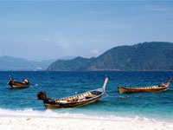 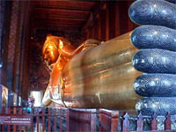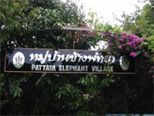

|  |  |
| --- | --- |
| **Day 01** | **Upon arrival Bangkok** |
|  | Upon arrival, meet & greet at the airport then transfer to the hotel. After check in, free & relax.  **Overnight in Bangkok** |
|  |  |
| **Day 02** | **Half Day Bangkok City Temple Tour. (B)** |
|  | Breakfast at hotel and then sightseeing tour to visit: At first visit to **Wat Traimit**, the Temple of the Golden Buddha, the temple is famous for its 900-years old five-and-a-half-ton solid gold image, and then continue to visit **Wat Arun**, perhaps better known as the Temple of the Dawn, is one of the best known landmarks and one of the most published images of Bangkok. After that, visit to **Wat Po**, the largest and oldest temple in Bangkok, as well as the largest single Buddha image: the Reclining Buddha (Phra Buddhasaiyas), also known as Wat Phra Chetuphon or The Temple of the Reclining Buddha. The temple is also known as the birthplace of traditional Thai massage Reclining Buddha. After this place we back to the hotel and free at leisure in the afternoon.  **Overnight in Bangkok** |
|  |  |
| **Day 03** | **Bangkok – Pattaya Coral Island. Join-in (B, L)** |
|  | After an early breakfast at hotel, we will depart for Pattaya where is one of the most destinations of tourist who love the beach, sunshine, nightlife and a lot of entertainments. Take about 2 hrs from Bangkok by road. Definitely, you have a chance to touch Koh Lan or Coral Island, the Popular Island for swimming, snorkeling, sun bathing on the flour-like sandy beach. Lunch is served at the Island . After lunch, free at leisure till we return back to Pattaya and check-in at the hotel and free at leisure.  **Overnight in Pattaya** |
|  | |
| **Day 04** | **Pattaya Half Day Nong Nooch Village Tour. Join-in(B)** |
|  | After breakfast at hotel sightseeing visit to **Suan Nong Nooch Village**, just 15 minutes east of Pattaya. Nong Nooch Tropical Garden has emerged as a fascinating tourist destination renowned for its wide-ranging orchid species, a palm garden, various flowering and decorative plants from all corners of the world. The highlight of the program and every bodys' favorite is the elephant show. You'll see these gentle giants, the symbols of Siam, perform various tricks such as riding bikes, playing football and they'll even invite you to a tug of war. You can quietly stroll among flower beds, enjoying the profuse colors and fragrance of millions of flowers, as well as the well-trained chimpanzees and elephants in the natural surroundings.   **Overnight in Pattaya** |
|  |  |
| **Day 05** | **Pattaya – Bangkok Departure. (B)** |
|  | After breakfast, free at leisure till time transfer to Bangkok airport for flight departure. |